Fall 2017: EUS 490 Special topics course: European borders without walls:
What can the world learn from EU borders and immigration policies?
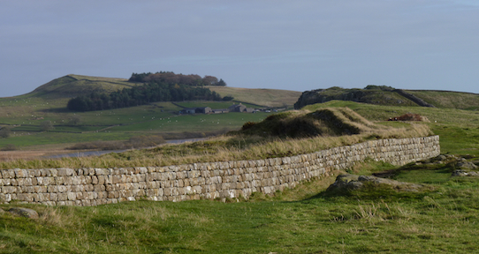

European borders without walls:
What can the world learn from EU border and immigration policies? An open online course. (EUS 490)
The current migration crisis is forcing Europeans to face past and future issues; and the decisions they are taking will have long standing impact on the EU. Our course hypothesises that answers to the crisis are shaping Europe’s borders, migration and related security policies in exemplary manners and should be studied in comparative perspective and context. To conduct this innovative and forward looking research, we primarily compare Canada, France, Japan and Turkey to leverage their tremendous expertise to compare EU’s evolving border, migration and security policies.
Activities are aimed at engaging the greater public, undergraduate and graduate students, young researchers and professors at each partner institution along with the policy makers in each community. The network will collectively develop a database of border, migration and related security policies, so that comparison of EU with the rest of the world is systematic and possible. Today, despite the growing body of work across institutions on border and migration studies, there are very few attempts to network these efforts, particularly when it comes to innovation in data sharing, management, and dissemination, hence this, Open Online course to teach how the EU border, migration and related security policies are evolved during the migration crisis.
Understanding borders in the twenty-first century is increasingly difficult. Borders are harder to define and manage and policy makers must deal with the multiple and complex activities of governments and the actions of private and public organizations across international boundaries.
In this free open - online survey course, you will learn about the history of borders and boundary making. You will explore what happens in cultural borderlands, and how current changes affect our understanding and the activities of governments as they face the many challenges related to borders and boundaries: migrations and trade, pandemics and sustainability issues, and security.
You will have access to a wide range of debates on the history, culture, economics, sustainability, security and governance of borders. Each unit uses a variety of learning activities including video-clips, short readings and online lectures. You can also choose to complete assignments and quizzes and participate in group discussions.
The course material, which you can follow at your own pace, will prepare you to compare North American and European borders and formulate ideas on both. Please visit the DCS website for the full course description.
This course is possible thanks to funding from the European Union Chair, Jean Monnet programs of the European Union. It is open on a non-credit basis to professionals in the public and private sector and community members with a strong interest in borders.
Themes:
History of borders – focus on the EU Cultures and borders – in North America and Europe Migrations and trading across borders Governance of borders in the mediterranean and in North America Sustainability – water issues in North America and in Europe Security – EU/North American differences and similarities The Case of EU Turkish relations The Case of EU Moroccan relations Borders and Migration in Canada Conclusions
The course is also open to UVic students as an undergraduate credit course (400 level), assessed according to university standards and subject to tuition fees. UVic students please contact eusprog@uvic.ca
Instructor: Emmanuel Brunet-Jailly, PhD, is a leading EU Border expert and the Director of the Jean Monnet Centre of Excellence and Jean Monnet Chair and Jean Monnet Network held by UVic since September 2015.
Dates: Monday, September 25 for 10 weeks – Registration is available on an ongoing basis until the end of the course week 10.
Fee: Free for non-credit participants
Code: ASHI634 2016F D01
Registration:
If you are interested in registering in the non-credit section of the course, you can do so directly through
Continuing Studies. UVic students interested in taking this course for credit, can register through their My Page,
CRN 11683.

